Spelling Dictionary of Common Errors

What is Spelling Dictionary of Common Errors
# Source: AI Source: Provided by: [Data Path: Persons Table -> ID Column: 1, Name_En Column: Motasem Essam] -> From: [Chatgpt (GPT-4-turbo)] on [7/30/2025]
A Spelling Dictionary of Common Errors is designed to help users recognize, understand, and correct frequently misspelled words. It focuses on the most common spelling mistakes made by learners or writers and explains the correct spelling alongside the incorrect versions.

✅ Key Features:
# Source: AI Source: Provided by: [Data Path: Persons Table -> ID Column: 1, Name_En Column: Motasem Essam] -> From: [Chatgpt (GPT-4-turbo)] on [7/30/2025]
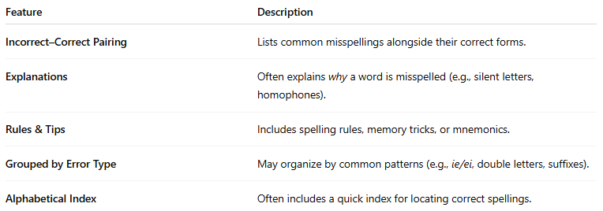
Feature | Description
Incorrect–Correct Pairing | Lists common misspellings alongside their correct forms.
Explanations | Often explains why a word is misspelled (e.g., silent letters, homophones).
Rules & Tips | Includes spelling rules, memory tricks, or mnemonics.
Grouped by Error Type | May organize by common patterns (e.g., ie/ei, double letters, suffixes).
Alphabetical Index | Often includes a quick index for locating correct spellings.

👤 Target Audience:
# Source: AI Source: Provided by: [Data Path: Persons Table -> ID Column: 1, Name_En Column: Motasem Essam] -> From: [Chatgpt (GPT-4-turbo)] on [7/30/2025]
- ESL/EFL learners
- Students (all levels)
- Writers and editors
- People with spelling challenges (e.g., dyslexia)

📘 Examples:
# Source: AI Source: Provided by: [Data Path: Persons Table -> ID Column: 1, Name_En Column: Motasem Essam] -> From: [Chatgpt (GPT-4-turbo)] on [7/30/2025]
- Spelling Dictionary of Common Errors
- The Spelling Troubleshooter
- Common Errors in English Usage (with a spelling focus)
- Collins Easy Learning Spelling

🟢 Benefits:
# Source: AI Source: Provided by: [Data Path: Persons Table -> ID Column: 1, Name_En Column: Motasem Essam] -> From: [Chatgpt (GPT-4-turbo)] on [7/30/2025]
- Directly addresses real spelling problems
- Builds awareness of error patterns
- Improves proofreading and editing skills
- Helps prevent repeated mistakes

🔴 Limitations:
# Source: AI Source: Provided by: [Data Path: Persons Table -> ID Column: 1, Name_En Column: Motasem Essam] -> From: [Chatgpt (GPT-4-turbo)] on [7/30/2025]
- Focuses only on problem words, not full vocabulary
- May not be useful for users with few spelling issues
- Lacks definitions or usage context in some versions

